* **Change table –**

|  |  |  |  |  |  |
| --- | --- | --- | --- | --- | --- |
| **Sr.**  **no** | **Change in colour** | **Description** | **suggestion** | **Suggested to** | **remarks** |
| **1.** |  |  |  |  |  |
|  |  |  |  |  |  |
|  |  |  |  |  |  |
|  |  |  |  |  |  |

B.K. Jewellers

**Business Requirement Document (BRD)**

**Document for**

**“Transfer” part.**

Document NO: 001

Date: 09-02-2020

Prepared by:

Group 2

* **Table of Contents** -

|  |  |
| --- | --- |
| 1. | Introduction |
|  | 1.1 Purpose |
|  | 1.2 Scope |
|  |  |
| 2. | General business requirements |
|  | 2.1 General requirement |
|  | 2.2 User characteristics |
|  |  |
| 3. | Business requirement |
|  |  |
| 4. | Use case diagram |
|  |  |
| 5. | Process description |
|  |  |
| 6. | Business data model |
|  |  |
| 7. | Accuracy |
|  |  |
| 8. | Impacts |

1. **Introduction**
   1. Purpose:

The purpose of making this business requirement document is to keep summary of transferred location for a particular item simpler and easier.

* 1. Scope:

The scope of this business requirement document is bounded to only location transfer process of **B.K. Jewellers**.

1. **General requirements**
   1. General requirements:

* Process can be done by Sales, Stock management and Manufacturing department only.
* Location transfer is required before let jewellery out of branch.
* Automatic voucher number is generated.
* Adding and removing of that particular item from the stock of receiver and sender.
* Printing receipts in pre-defined format automatically.
  1. User characteristics:

|  |  |  |
| --- | --- | --- |
| Name | No. Of user | Responsibility/activity |
| Salesman | 5 | He/she should have 80% of computer knowledge and 100% of knowledge of jewellery location transfer process. |
| Sales manager | 1 | He/she should have 80% of computer knowledge and 100% of knowledge of jewellery location transfer process. |
| Stock manager | 1 | He/she should have 80% of computer knowledge and 100% of knowledge of jewellery location transfer process. |
| Manufacturing head | 1 | He/she should have 80% of computer knowledge and 100% of knowledge of jewellery location transfer process. |

1. **Business requirement**

|  |  |
| --- | --- |
| 1. | Login |
| Priority | High |
| Originator | Managing director |
| Inputs | Username and password from text fields submit and reset from a button. |
| Operations | When username and password is added, values will validate. |
| Outputs | If successful, user will navigated into software else the text fields will become red. |
| Error handling | If the inputted data is incorrect it will show an alert message “username and password is wrong!!”. |
| User need | User needs this for login to the software. |
| Benefits | First level of security to access the software. |

|  |  |
| --- | --- |
| 2. | Voucher number generation |
| Priority | High |
| Originator | Managing director |
| Inputs | N/A  Note: automatically done by software. |
| Operations | Check the number from last submitted voucher and does one increment in that number. |
| Outputs | Display the new incremented number at respective place in preformatted voucher. |
| Error handling | If software is unable to generate new number then it will leave the space blank on voucher, user will have to notice it and try again to create new voucher. |
| User need | User needs this requirement for giving a unique reference number to each voucher. |

|  |  |
| --- | --- |
| 3. | Scanning |
| Priority | High |
| Originator | Managing director |
| Inputs | Adding values by barcode scanner only. |
| Operations | When barcode was scanned following details of an item will get searched code, image, weight and price of particular item. |
| Outputs | Display the searched details at respected places. |
| Error handling | If software can’t find details, it leaves respective space blank then user will have to scan again.  If barcode is not scanned, scanning stops at that position then user will have to scan barcode again. |
| User need | User needs this requirement to add items for location transfer. |
| Benefits | User doesn’t need to type code of every item. |

|  |  |
| --- | --- |
| 4. | Removing and printing |
| Priority | High |
| Originator | Managing director |
| Inputs | N/A  Note: Done automatically. |
| Operations | When submit button is clicked selected items will be removed from the stock of current location and voucher sent to get printed via connected printer. |
| Outputs | If successful user will see a massage “Transfer successful”. |
| Error handling | If software is unable to generate voucher, an alert massage will shown “Unable to generate voucher, please try again.”.  If barcode not scanned, user will have to scan it again for moving ahead. |
| User need | User needs this requirement for managing stock on particular branch. |
| Benefits | Location of any item can be identified. |

1. **Use case diagram**

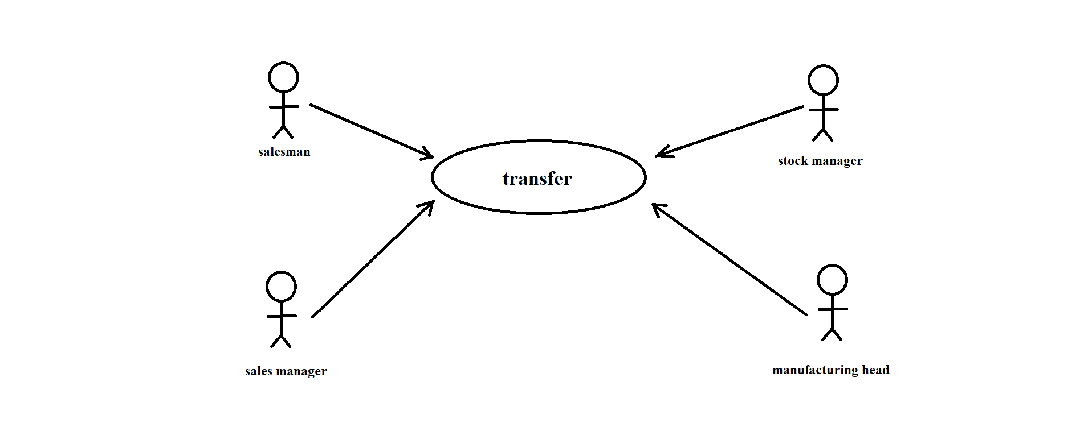

|  |  |
| --- | --- |
|  | Indicates module. |
|  | Indicates access/rights. |
|  | Indicates users. |

1. **Process description**

|  |  |
| --- | --- |
| Details | Process Description |
| Process Name | Login |
| Purpose | It should be the first process for entering to software. |
| priority | High |
| Frequency/Duration | Login process should not more than 2seconds to complete and navigate the user to the main page of the software. |

|  |  |
| --- | --- |
| Details | Process Description |
| Process Name | Voucher number generation. |
| Purpose | It should be the first process done for making a new transfer voucher. |
| priority | High |
| Frequency/Duration | This process will take maximum 0.5 seconds to get completed. |

|  |  |
| --- | --- |
| Details | Process Description |
| Process Name | Barcode scanning. |
| Purpose | It should be the process done to enter items for location transfer in list. |
| priority | High |
| Frequency/Duration | This process will take maximum 0.5 – 0.8 seconds to scan one barcode. |

|  |  |
| --- | --- |
| Details | Process Description |
| Process Name | Removing items from current location. |
| Purpose | It should be the process done after user submits the voucher. |
| priority | High |
| Frequency/Duration | This process will take maximum 2 seconds to get completed. |

|  |  |
| --- | --- |
| Details | Process Description |
| Process Name | Printing. |
| Purpose | It should be the process done after user submits the voucher. |
| Priority | High |
| Frequency/Duration | This process will take maximum 3 seconds to get completed. |

1. **Business data model**

**---------(N/A)---------**

Note: insufficient knowledge.

1. **Accuracy**

The accuracy will always be higher in any of the functions which can be done by the software even in printing the vouchers. All the automatic processes will be completed with very high level of accuracy in the results generated by them.

1. **Impacts**

**---------(N/A)---------**

Note: first phase of making software.